City of Nashua Conservation Commission
City Hall
229 Main Street
Nashua, NH 03061

Re: Fire Training Facility at Four Hills Landfill (25 Teak Drive / 840 West Hollis Street)
PFAS Contamination, Wetland Buffer Impacts, Vernal Pool Resources, and Need for Comprehensive Review

Dear Members of the Conservation Commission,

I am writing to submit formal comments regarding the City of Nashua Department of Public Works proposal to connect water service to a yet to be proposed Fire Training Facility within the Four Hills Landfill property. This item appears under Old Business on the February 3, 2026 Conservation Commission agenda and properties located at 25 Teak Drive and 840 West Hollis Street (Map C-1320 and D-54, Lot 109, Ward 5).
While the agenda item is framed as a water service connection, this work is not a standalone utility improvement. It is an enabling component of the proposed Fire Training Facility and must be evaluated in the context of the full scope of environmental impacts associated with that facility, particularly given its proximity to regulated wetlands, wetland buffers, and vernal pool resources.
Earlier representations regarding the Fire Training Facility suggested that chemical impacts were not anticipated. However, the City’s own recent actions demonstrate that this is no longer the case. In January 2026, the City approved a contract in the amount of $236,800 for a PFAS Site Investigation and Evaluation at the Fire Training Area within the Four Hills Landfill. This work includes soil and groundwater sampling, installation of monitoring wells, laboratory testing, and reporting to the New Hampshire Department of Environmental Services pursuant to Env-Or 600 requirements.
The agenda item itself acknowledges impacts to wetland buffers in the vicinity of Teak Drive. Mapping and aerial imagery identify surface water features immediately adjacent to the proposed Fire Training Facility location, including a feature consistent with a potential vernal pool located less than 100 feet from the proposed facility site.
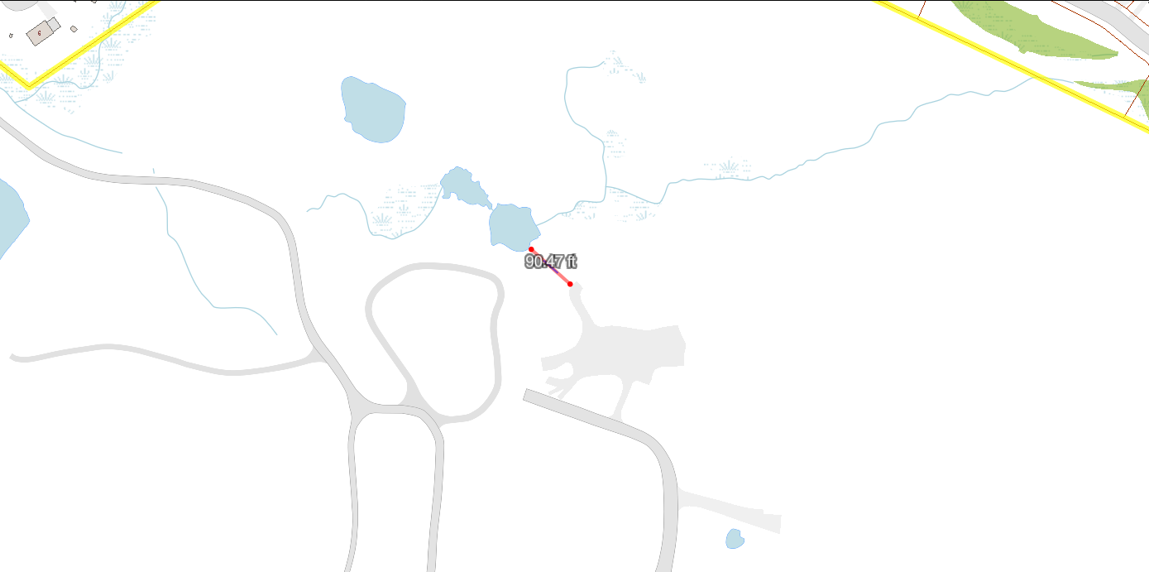
Figure 1: Map showing the measured distance (~90 feet) between the proposed Fire Training Facility
location and an adjacent surface water feature consistent with a potential vernal pool.
Source: https://nashuagis.nashuanh.gov/
The Teak drive vernal pool located approximately 1000 feet upstream within the same watershed has previously been evaluated by qualified professionals and documented as biologically rich, supporting fairy shrimp and other vernal pool-dependent species with reported sightings of endangered species of turtles, birds and snakes. The presence of fairy shrimp is a widely recognized indicator of a high-quality vernal pool ecosystem.
PFAS compounds are highly persistent, resistant to natural degradation, and mobile in groundwater. Once released into interconnected wetland systems, they are extremely difficult and costly to remediate. The City’s own consultant has indicated that anticipated responses may rely on soil capping and long-term management rather than full removal of contamination.
Residents have growing concerns regarding the limited and piecemeal disclosure of information related to the proposed Fire Training Facility. Individual components of the project appear to be advancing prior to full public disclosure of facility plans and environmental analyses.
Residents of Teak Drive and neighboring streets, together with residents of the Westgate community, are preparing to submit a formal request for a comprehensive environmental assessment and zoning review to strengthen long-term protections for vernal pools and connected wetland systems in this area. In addition, that request will include a review of downstream waterways and associated surface water features within this connected system to determine whether they meet the criteria for vernal pool designation. Given the documented presence of abundant and diverse wildlife in confirmed at the Teak Dr. vernal pool located less than 1,000 feet upstream, it is reasonable to question whether downstream pools within the same hydrologic network also support biologically diverse communities. A science-based assessment is therefore warranted to ensure these resources are properly identified and protected.
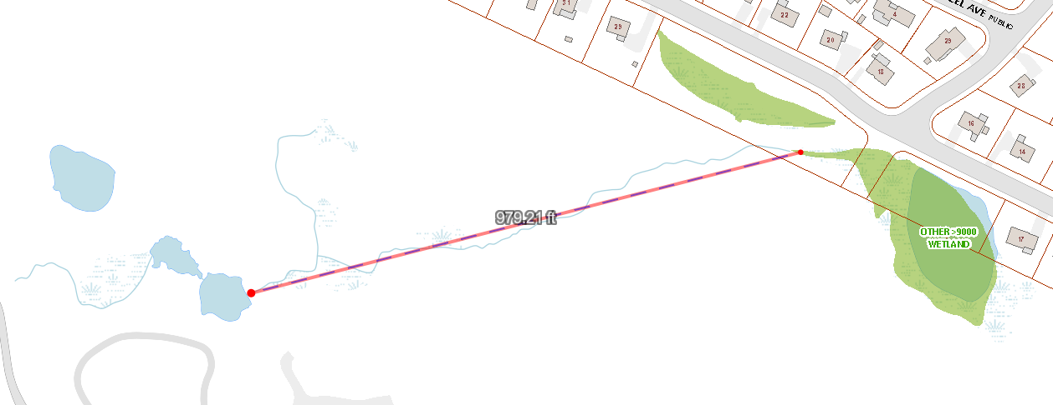
Figure 2: Mapping illustrating the approximate distance (~979 feet) between a confirmed
upstream vernal pool and downstream surface water features within the same hydrologic system.
Source: https://nashuagis.nashuanh.gov/
Given the acknowledged PFAS contamination, proximity to wetlands and vernal pool resources, and lack of a complete and transparent project review, a precautionary approach is warranted. I respectfully urge the Conservation Commission to require a higher level of environmental review before allowing further approvals to proceed.

Respectfully submitted,

_______________________________
Rody Arantes

